SECTION THREE: EXTENDED RESPONSE
FOR ALL CANDIDATES (40 MARKS)

Choose only two of the following four questions to answer.

Write your answer on the lined pages provided.

Suggested working time for this section is 60 minutes.

Question 1 (20 Marks)

Paceman’s physical and emotional battle with injury takes toll

For copyright reasons this article cannot be reproduced in the online version of this document.

Adapted from an article in the West Australian newspaper, January 2008

In relation to this sudden announcement of a highly talented young cricketer’s retirement:

(a) Identify and explain the impact of a key physical, mental and social factor that played a role in this particular case of burnout.
(6 marks)

(b) As his coach, develop and justify holistic strategies to facilitate both his mental and physical recovery to play elite cricket again, including:
- goal setting
- managing stress and anxiety
- decision making
(7 marks)

(c) You attended a recent coaches’ conference at which a key topic of discussion was
‘Cricket authorities do not and should not have a role in player burnout’. Present an argument against this proposition by addressing factors related to holistic, long term player wellbeing, including codes of ethics in sport.
(7 marks)

OR

Question 2 (20 Marks)

Using your knowledge of environmental conditions, select an outdoor team sport that you are familiar with and explain how you would adjust your skills, tactics and strategies to optimise your performance in the following situations:

- wet weather
- hot, dry conditions
- freezing conditions
- windy conditions

OR

Question 3 (20 Marks)

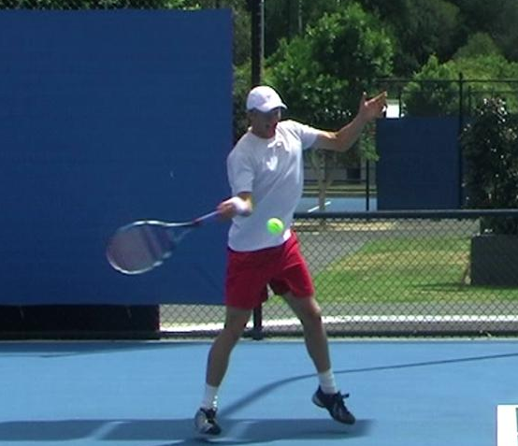

(a) Describe the optimal sequencing of body parts involved in performing a well coordinated tennis forehand stroke as shown in the picture above. Integrate movement (biomechanical) principles into the optimal sequencing that you suggest to help justify your answer.
(5 marks)

(b) Hitting the forehand with topspin can make a ball’s trajectory change compared to hitting the ball with backspin or with no spin. Draw a graph showing the expected trajectories of tennis balls hit with topspin, backspin and no spin (assume all other factors contributing to ball trajectory are constant). (5 marks)

Explain the different trajectories using movement (biomechanical) principles (you may use diagrams to illustrate your response).
(10marks)
OR

Question 4 (20 Marks)

Volleyball is a net-divided team game in which players attempt to score points by hitting the ball into the unguarded spaces of the opponent’s court. Players who form the team require a number of key physical variables such as hand-eye coordination, reaction time, anticipation, agility and leg power.

Table 1

(a)
(3 marks)

For copyright reasons some parts of question 4 cannot be reproduced in the online version of this document, but can be viewed on page 15 & 16 of website: http://www.vcaa.vic.edu.au/vce/studies/physicaledu/pastexams/2003_physed.pdf

Table 2

(b) (2 marks)

(c)

(6 marks)

(d) An analysis of the athlete’s movement on court identifies relatively poor agility.
The coach decides to include martial arts and running as part of the athlete’s agility conditioning program. Discuss how these additional activities improve the player’s agility by referring to the following coaching and learning principles.

- Specificity of training (2 marks)

- Cross training (2 marks)

- Transfer of training (2 marks)

(e) To prepare the team for the upcoming national championships the coach devises simulation drills. Define what is meant by simulation drills and explain why the coach would use simulation drills.
(3 marks)

